Business Admin App
Config file
"AzureAd": {
"Instance": "https://login.microsoftonline.com/",
"Domain": "cnb.onmicrosoft.com",
"TenantId": "3a0fdda6-105d-4fce-bb8a-1ed83b71e72b",
"ClientId": "f9aad074-6a16-467f-8c05-d9154aaa8012",
"ClientSecret": "Ye6DulkNdWczLEl-C1y0HhbYChrKHtxt",
"CallbackPath": "/signin-oidc"
}
"DistributedCache": {
"TableName": "AppCache",
"Enabled": false
}
WalkMeUrl
"Security": {
"Encryption": {
"Key": "4d89g13j4j91j27c582ji693=VQ1245nb",
"Code": "x7wdKbpoWErT"
},
"RingKey": {
"ApplicationName": "unified-applications",
"Directory": "/usr/share/app/keys"
},
"Timeout": {
"Countdown": 30
}
}
"Cdn": {
"Enabled": "true",
"Url": "https://cno.sit.cnb.com/static/assets/libs"
}
"Exception": {
"EnableExceptionDetails": false,
"EnableClientExceptionDetails": false,
"ErrorPagePath": "/Error"
}
"Serilog": {
"WriteTo": [
{
"Name": "Console",
"Args": {
"formatter": "Serilog.Formatting.Json.JsonFormatter"
}
}
],
"Enrich": [
"WithMachineName",
"WithEnvironmentUserName",
"WithAssemblyName",
"WithAssemblyVersion",
"WithProcessName",
"WithProcessId",
"WithThreadId",
"WithThreadName",
"WithMemoryUsage",
"WithExceptionDetails",
"FromLogContext"
],
"Properties": {
"AppType": "application",
"AppName": "Business-Admin",
"Environment": "prd",
"Team": "0",
"Release": ""
}
}
"Cache": {
"ExpirationTime": "5"
},

Startup file
services.AddApplicationInsightsTelemetry();
services.AddApplicationInsightsKubernetesEnricher();

services.RegisterCompanyService(Configuration.GetSection("ApiConfiguration:Company").Get<CompanyServiceConfig>());

services.AddDistributedSqlServerCache(opt =>
{
opt.ConnectionString = Configuration.GetConnectionString("SQL:DistributedCache");
opt.SchemaName = "dbo";
opt.TableName = Configuration["DistributedCache:TableName"];
});

services.RegisterWebSealMiddleware();
services.AddHttpContextAccessor();

services.AddAuthentication(AzureADDefaults.AuthenticationScheme)
.AddAzureAD(options => Configuration.Bind("AzureAd", options));

services.AddMvc(options =>
{
var policy = new AuthorizationPolicyBuilder()
.RequireAuthenticatedUser()
.Build();
options.Filters.Add(new AuthorizeFilter(policy));
})
.SetCompatibilityVersion(CompatibilityVersion.Version_2_1);

services.Configure<ForwardedHeadersOptions>(options =>
{
options.ForwardedHeaders = ForwardedHeaders.XForwardedFor |
ForwardedHeaders.XForwardedProto;
// Only loopback proxies are allowed by default.
// Clear that restriction because forwarders are enabled by explicit
// configuration.
options.KnownNetworks.Clear();
options.KnownProxies.Clear();
});

Pages
<partial name="~/Views/Shared/CompanyEnroll/_CompanyHeader.cshtml" model="Model.CompanyHeader" />
Html.Kendo().DropDownList()
.Name("TimeZone")
.HtmlAttributes(new { @class = "fixedWidth dropdownFont", name = "EnrollModel.TimeZone" })
.DataTextField("name")
.DataValueField("timeZoneID")
.DataSource(source =>
{
source.Read(read => { read.Url(Junction + "/Lookup/GetTimeZone"); });
}).Value(Model.EnrollModel.TimeZone)

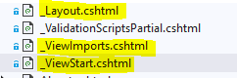

@using WebApp
@namespace WebApp.Pages
@addTagHelper *, Cnb.Platform.Applications.Extension.CdnTagHelpers
@addTagHelper *, Cnb.Platform.Applications.Extension.TeaLeafTagHelpers
@addTagHelper *, Microsoft.AspNetCore.Mvc.TagHelpers

StartupBase.cs

Exception handling has been injected as a filter attribute

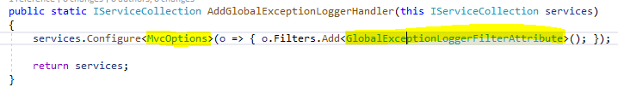

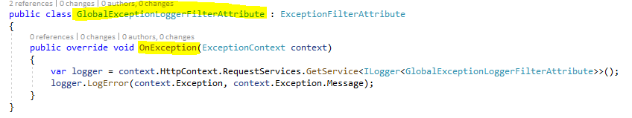

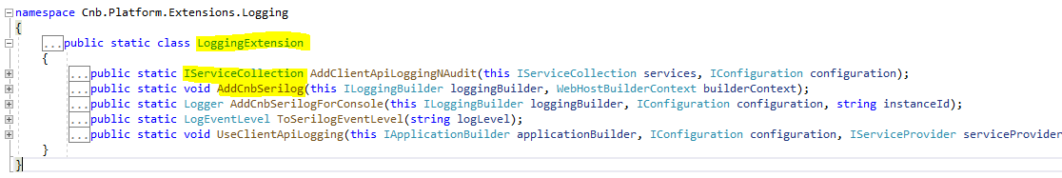

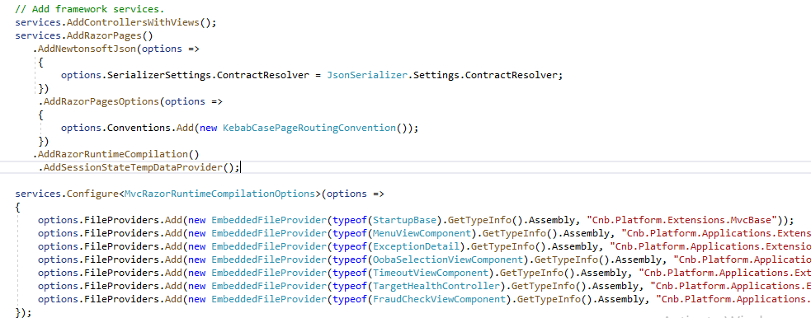

MvcRazorRuntimeComplilationOptions , File Providers are used to register razor pages with in the library files

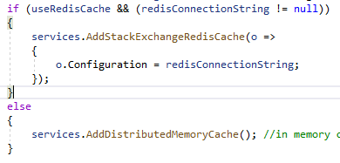

AddSingleton
AddTransient
AddScoped

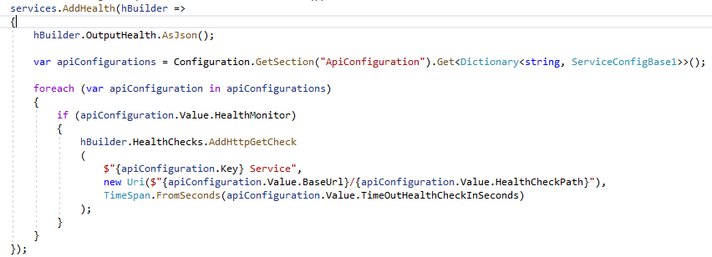
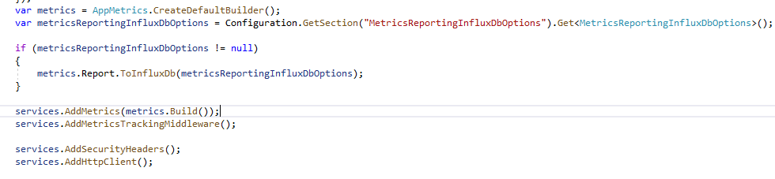
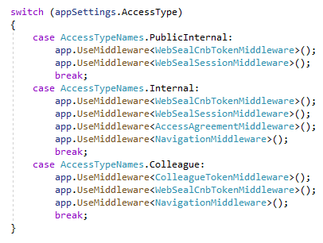

User Application

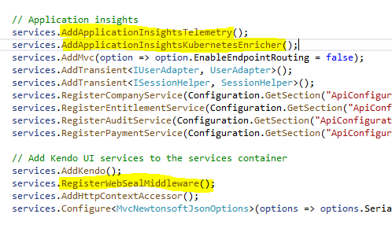

Navigation Middleware

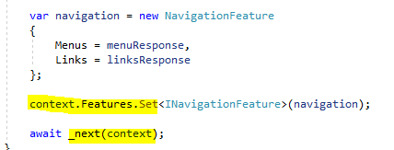
Web seal middleware token

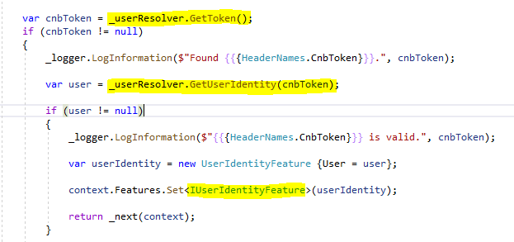

SeriLog

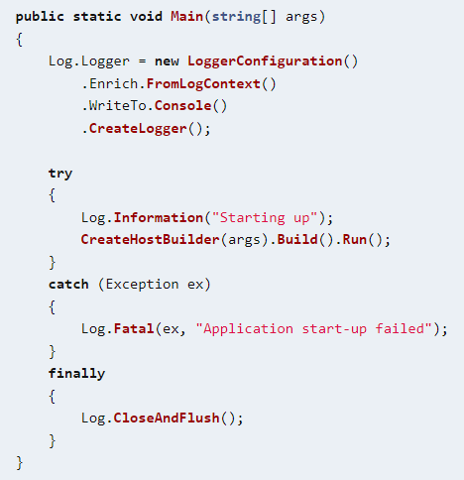

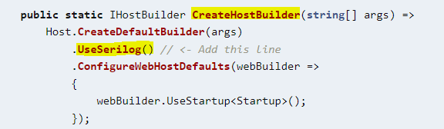

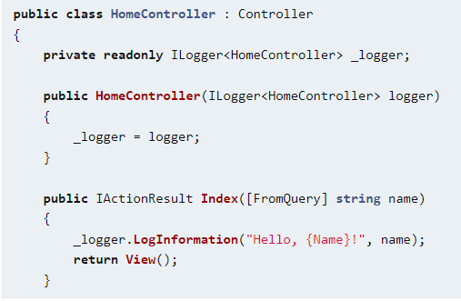
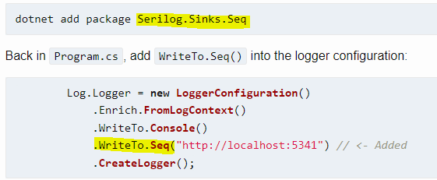
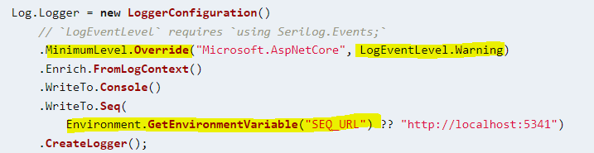

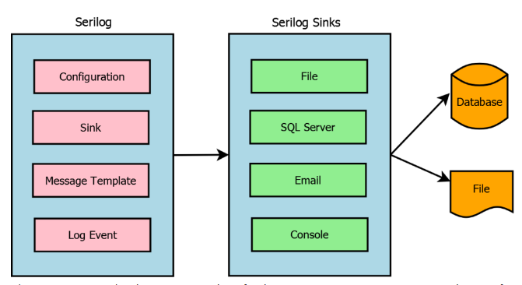
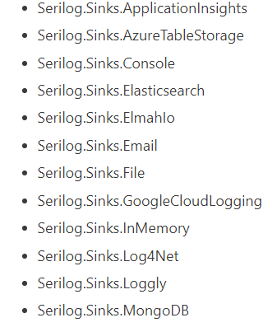

Install Seq server , we can log into that , provide nice UI interface

View Component

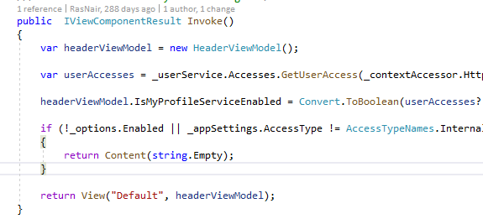

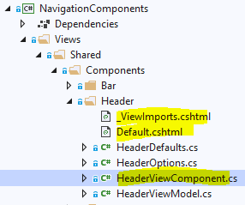

User Service

Contract

Interfaces implemented in service , models used in api , request and response

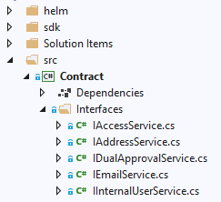

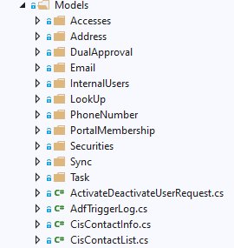

Service project

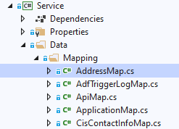

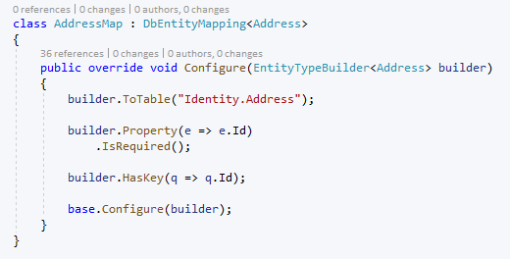

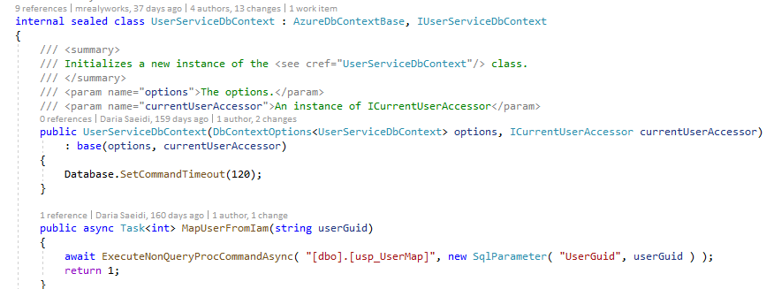

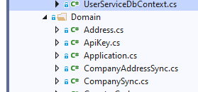
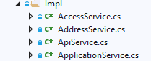
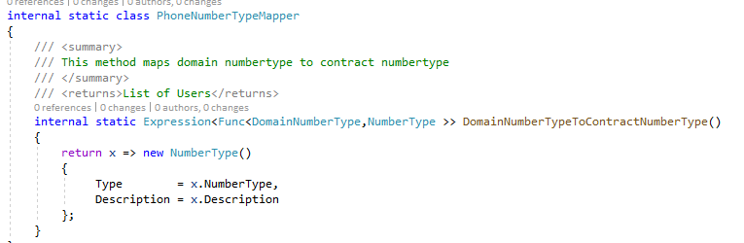
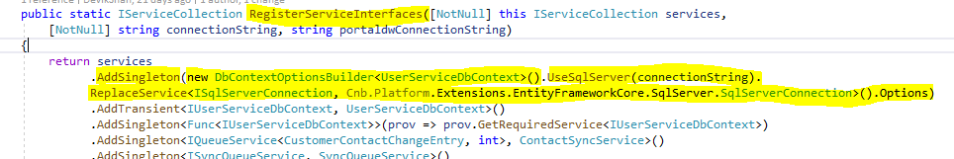
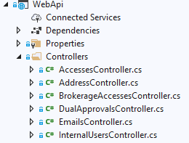
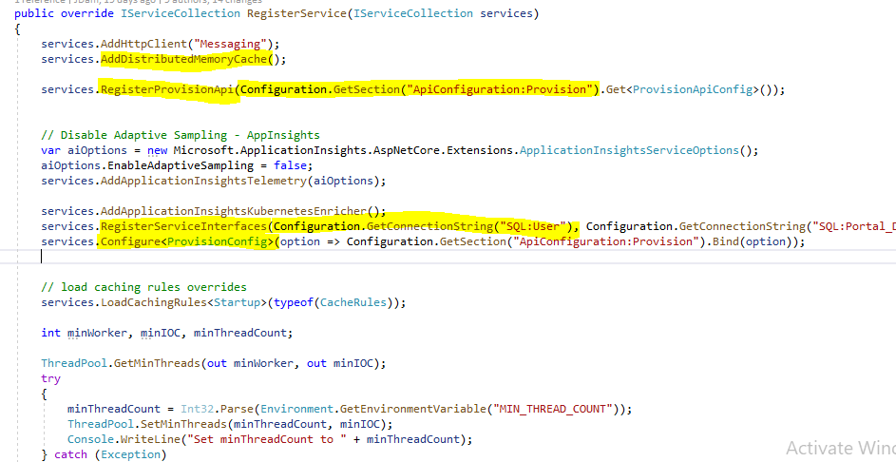

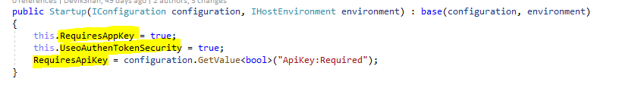
The above properties are part of startup base

Extension Services

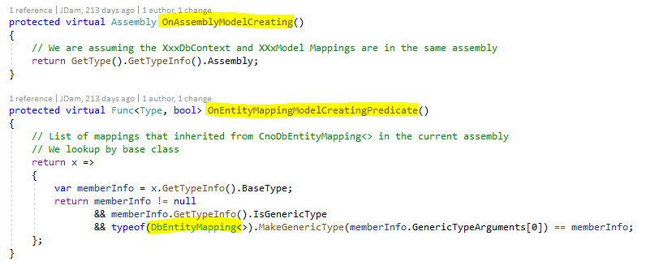

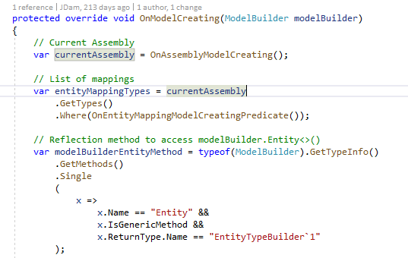
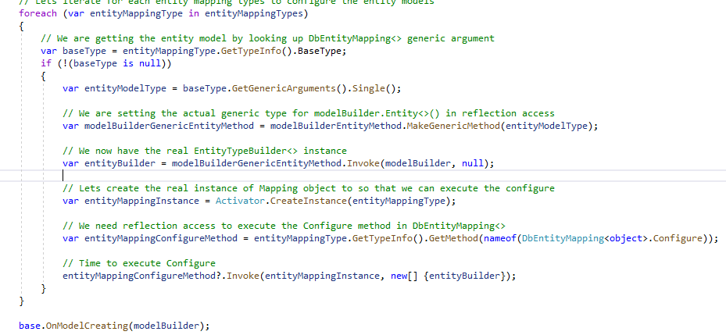

StartupBase

services.AddClientApiLoggingNAudit(Configuration);
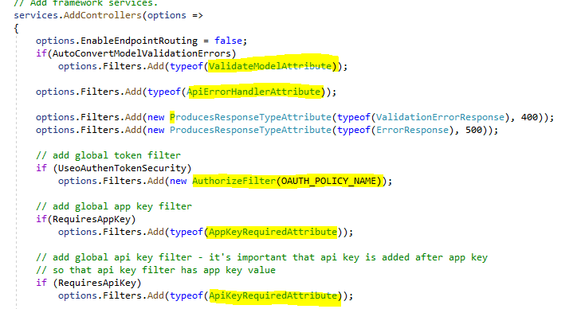
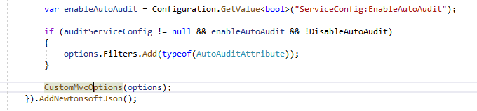

Bottomline Gateway Service

Azure Authentication

services.AddAuthentication(AzureADDefaults.AuthenticationScheme)
.AddAzureAD(options => Configuration.Bind("AzureAd", options));

"AzureAd": {
"Instance": "https://login.microsoftonline.com/",
"Domain": "cnb.onmicrosoft.com",
"TenantId": "3a0fdda6-105d-4fce-bb8a-1ed83b71e72b",
"ClientId": "f9aad074-6a16-467f-8c05-d9154aaa8012",
"ClientSecret": "Ye6DulkNdWczLEl-C1y0HhbYChrKHtxt",
"CallbackPath": "/signin-oidc"
}

Azure Authentication: Two options

Option 1: Upload a certificate

Option 2: Create a new application secret

Distributed Cache
When cached data is distributed, the data:
- Is coherent (consistent) across requests to multiple servers.
- Survives server restarts and app deployments.
- Doesn't use local memory.

Regardless of which implementation is selected, the app interacts with the cache using the IDistributedCache interface.
To use a SQL Server distributed cache, add a package reference to the Microsoft.Extensions.Caching.SqlServer package.
To use a Redis distributed cache, add a package reference to the Microsoft.Extensions.Caching.StackExchangeRedis package.
The IDistributedCache interface provides the following methods to manipulate items in the distributed cache implementation:
- Get, GetAsync: Accepts a string key and retrieves a cached item as a byte[] array if found in the cache.
- Set, SetAsync: Adds an item (as byte[] array) to the cache using a string key.
- Refresh, RefreshAsync: Refreshes an item in the cache based on its key, resetting its sliding expiration timeout (if any).
- Remove, RemoveAsync: Removes a cache item based on its string key.

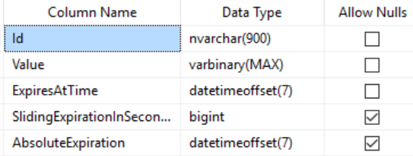

builder.Services.AddDistributedSqlServerCache(options =>
{
options.ConnectionString = builder.Configuration.GetConnectionString(
"DistCache_ConnectionString");
options.SchemaName = "dbo";
options.TableName = "TestCache";
});

Redis Cache

builder.Services.AddStackExchangeRedisCache(options =>
{
options.Configuration = builder.Configuration.GetConnectionString("MyRedisConStr");
options.InstanceName = "SampleInstance";
});

services.AddApplicationInsightsTelemetry();

{
"ApplicationInsights": {
"InstrumentationKey": "putinstrumentationkeyhere"
},
"Logging": {
"LogLevel": {
"Default": "Warning"
}
}
}

This article describes how to enable Application Insights for an ASP.NET Core application. When you complete the instructions in this article, Application Insights will collect requests, dependencies, exceptions, performance counters, heartbeats, and logs from your ASP.NET Core application.

services.AddApplicationInsightsKubernetesEnricher();

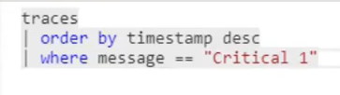

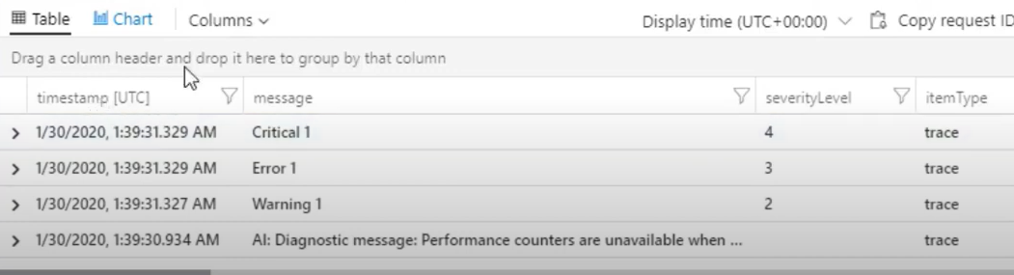

Operation_ParentId Same http request
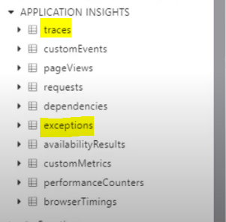

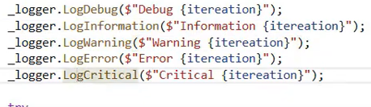
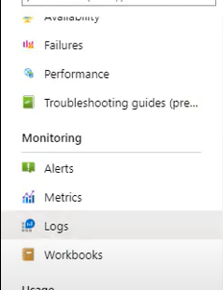

AddressMap : DbEntityMapping<Address>
{
public override void configure(EntityTypeBuilder<Address> builder)
{
builder.ToTable("Identity.Address");
builder.Property(e=>e.Id).IsRequired();
builder.HasKey(q=>q.Id);
}
}

